* Design PDA using simulator to accept the input string anb2n

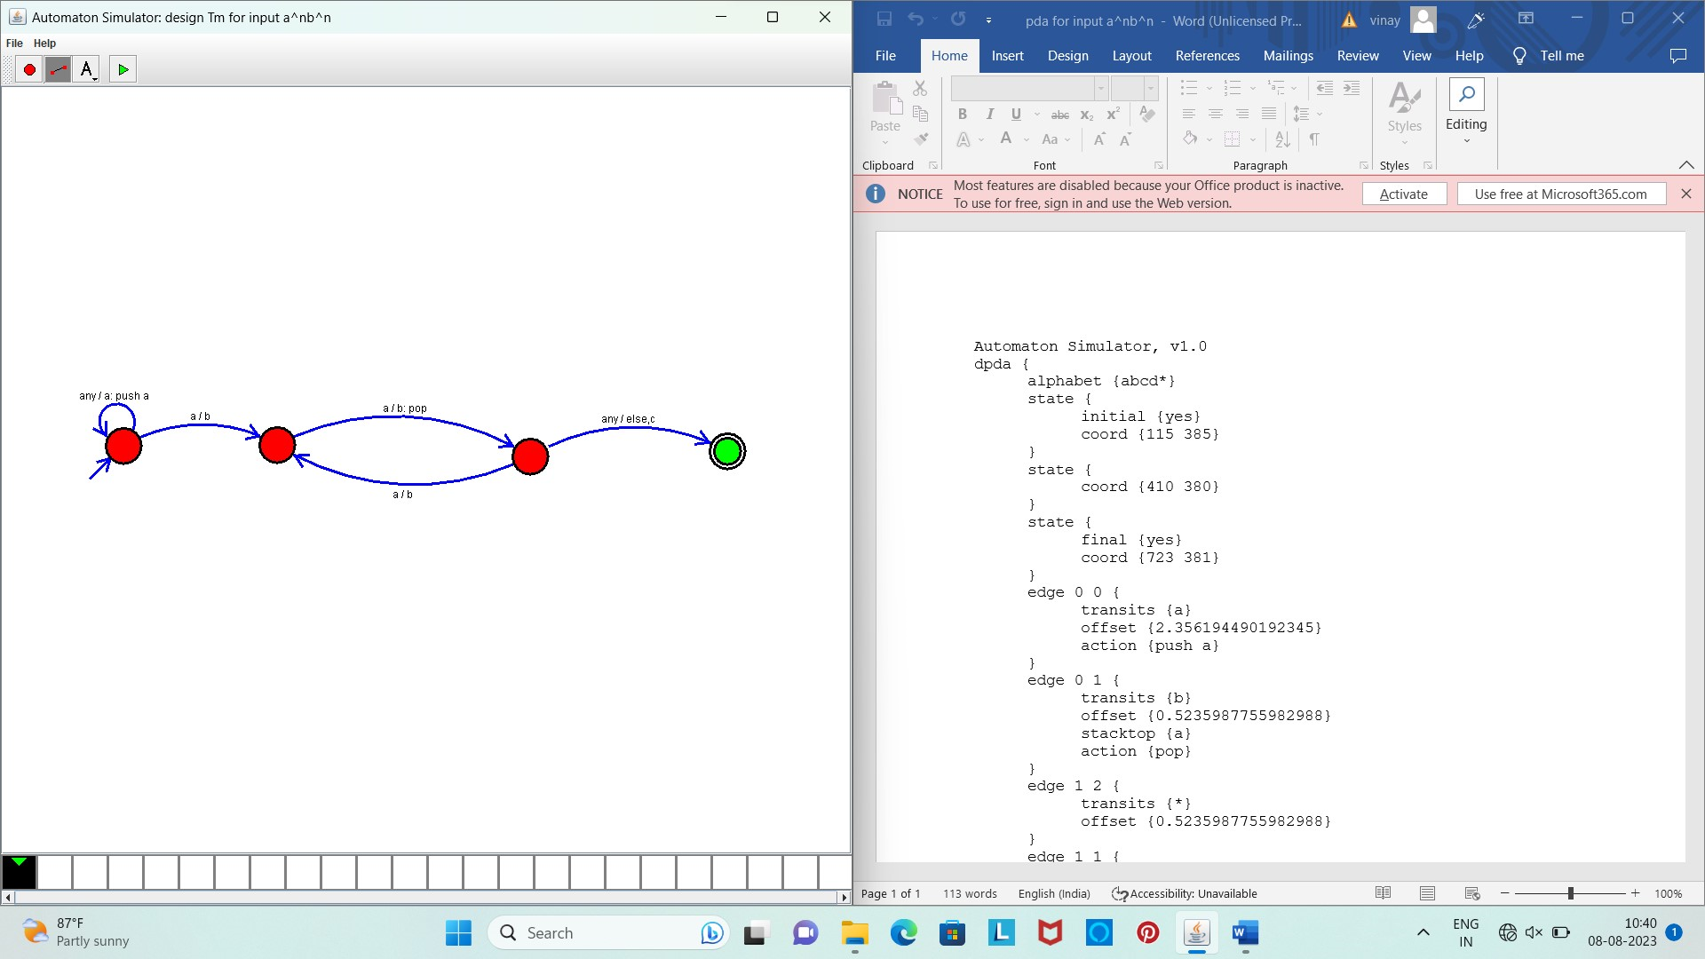

Result :

* The simulator is accepted the given input string anb2n by using the above PDA diagram